TABLE OF CONTENTS

Contents

Objective 1

Login to IPC Cluster 2

Setup IBM Cloud Private CLI 2

Setup Kubernetes  CLI 2

Setup Helm CLI 2

Connect to cluster via Local Terminal 2

Setup local Docker Client for ICP Docker Registry 4

Push Image to ICP Docker Registry 4

Deploy Patient Match via Helm Chart 5

Access Container Logs as Stream 7

Access your service 7

Revision History

|  |  |  |  |
| --- | --- | --- | --- |
| Date | Version | Author | Action - Comment |
| 10/21/2019 | 1.0.0 | Rajan Gupta | Created – Manual Service Deployment |
|  |  |  |  |
|  |  |  |  |

# Objective

Quick Guide on how to deploy Microservice to Phytel IBM Cloud Private Cluster. This document captures different steps starting with setup, configure, deployment of service to ICP via local Terminal.

Once CI/CD is built for Phytel IPC Cluster, most of these steps will be automated.

# Login to IPC Cluster

* Access Get Started

<https://10.231.186.12:8443/console/welcome>

# Setup IBM Cloud Private CLI

* Install cloudctl

<https://10.231.186.12:8443/console/tools/cli>

# Setup Kubernetes  CLI

* Install kubectl

<https://10.231.186.12:8443/console/tools/cli>

# Setup Helm CLI

* Install helm

<https://10.231.186.12:8443/console/tools/cli>

# Connect to cluster via Local Terminal

* Access Configure Client from Profile icon

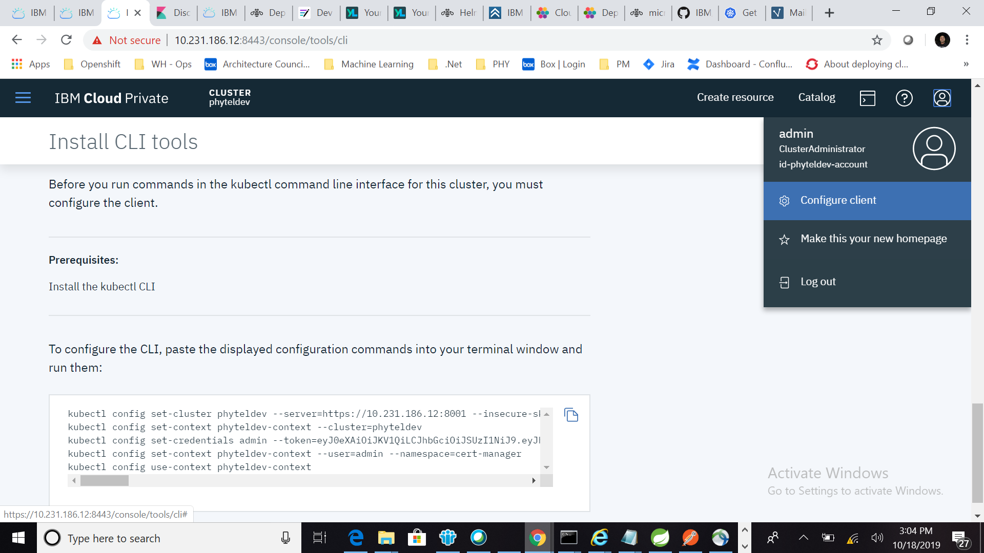

* Copy kubectl command from Configure Client

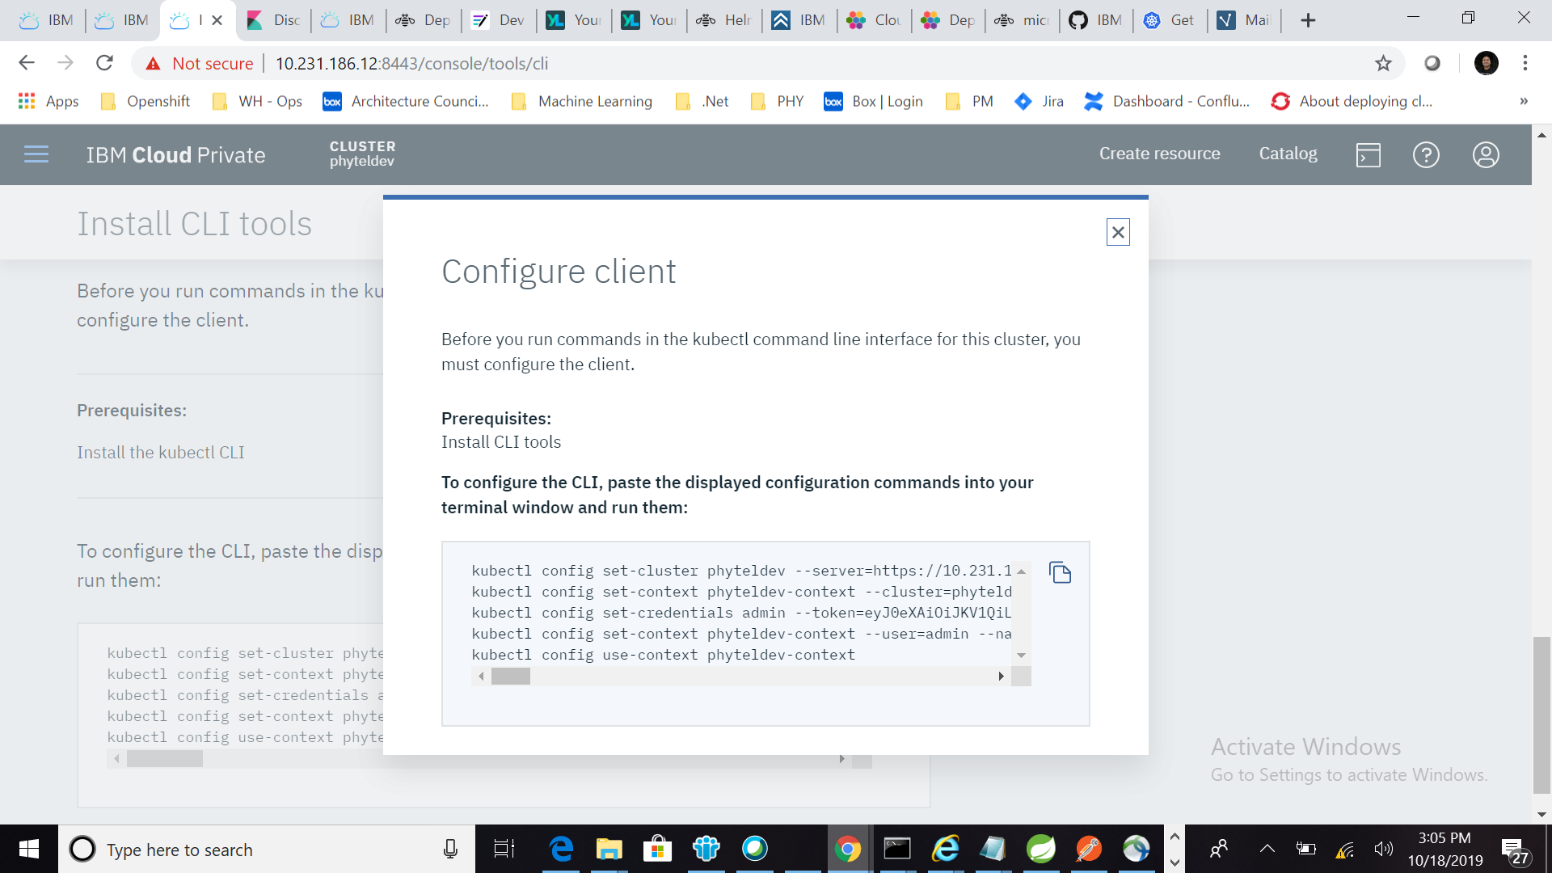

* Run kubectl command copy in previous step

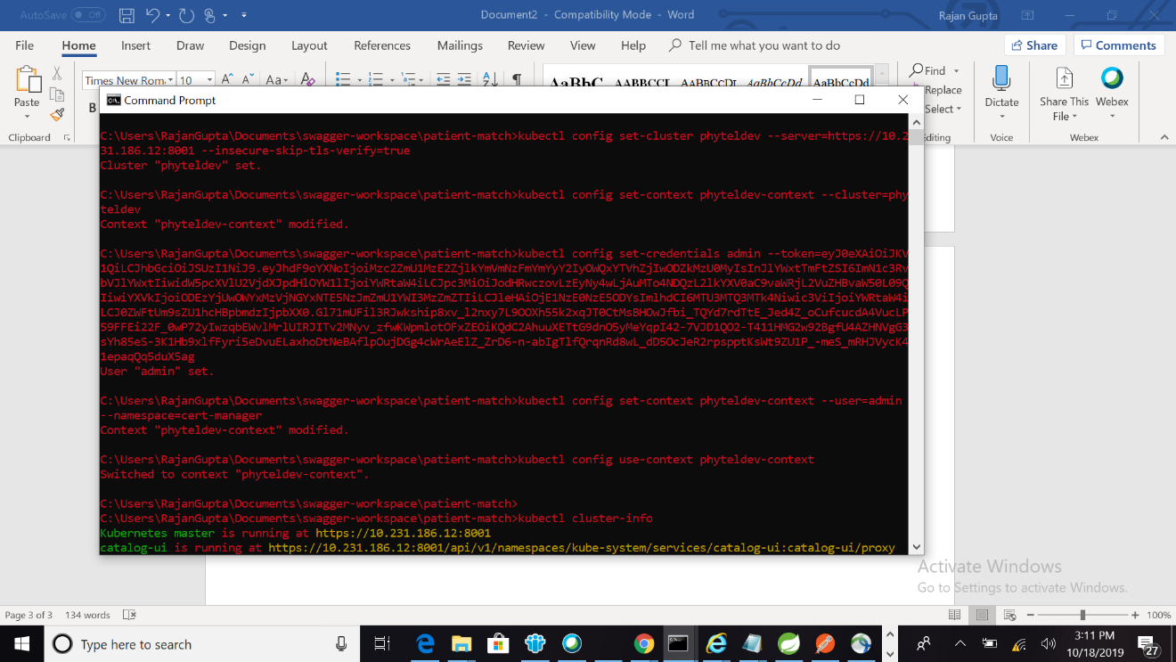

* Verify kubectl CLI is connected to ICP

Run kubectl cluster-info

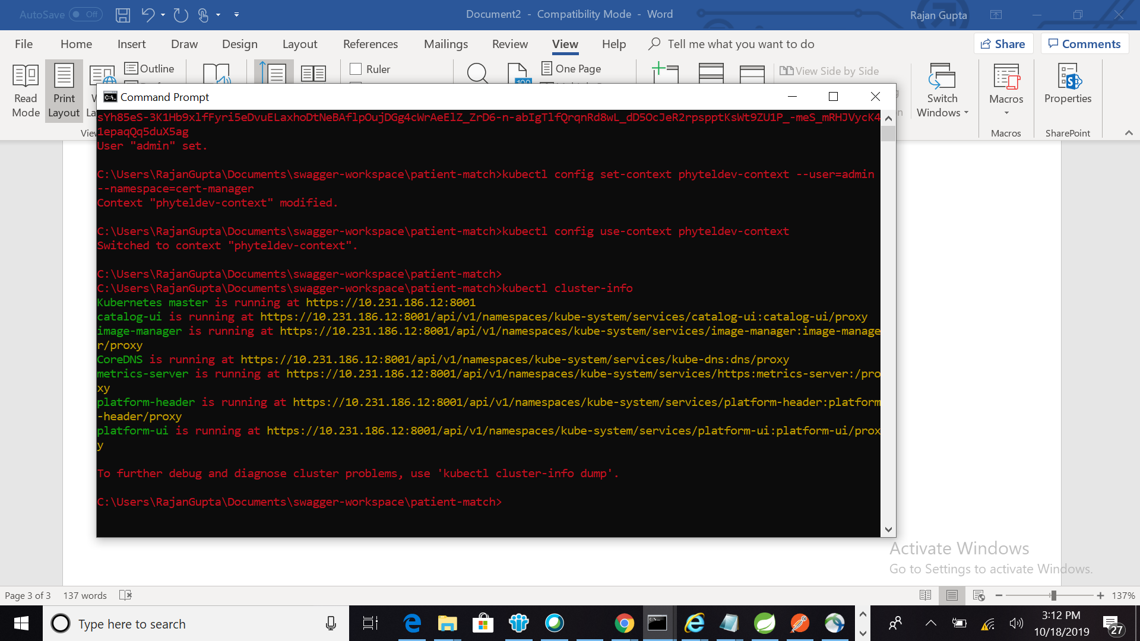

* Verify Cloudctl CLI is connected to ICP (Not Working for me)

Run cloudctl api

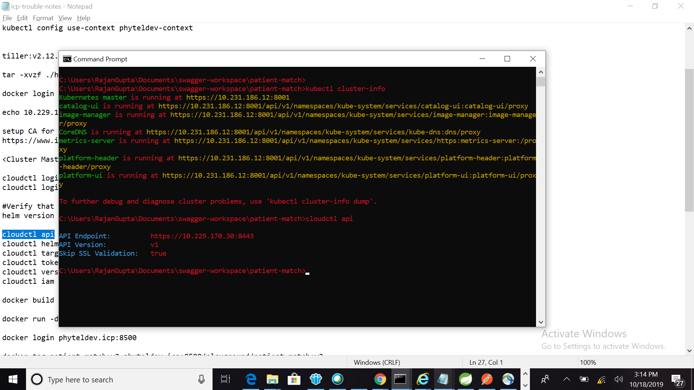

(Below is my error)

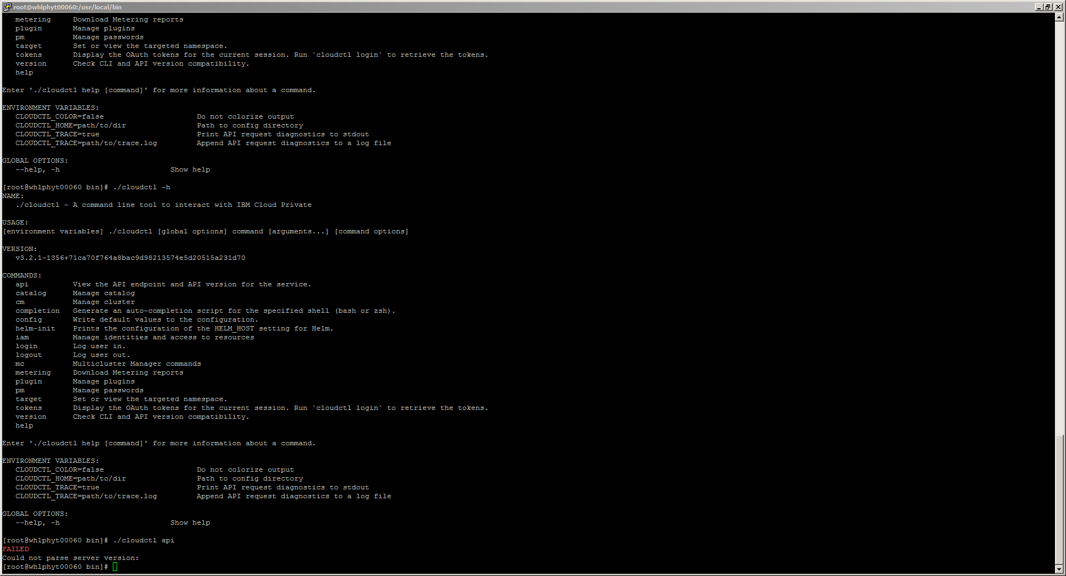

# Setup local Docker Client for ICP Docker Registry

* Setup docker certs (The is no file in below path)

Certs path: <https://ibm.ent.box.com/folder/90050103138>

<Cluster Master Host> <cluster_CA_domain> = 10.229.170.30 phyteldev.icp

Instructions to import certs to ca

https://www.ibm.com/support/knowledgecenter/SSBS6K_3.2.1/manage_images/configuring_docker_cli.html

Connect docker client: Run command and provide ICP login credentials when ask

docker login phyteldev.icp:8500

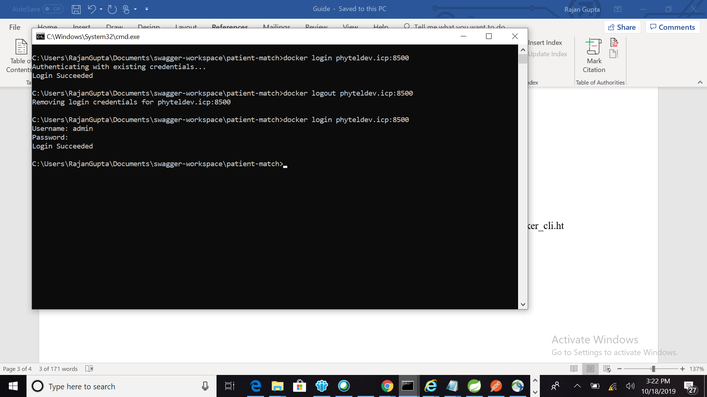

# Push Image to ICP Docker Registry

* Build Docker Image locally:

Go to root of your application make sure Dockerfile is in place

docker build -t patient-match:v1 .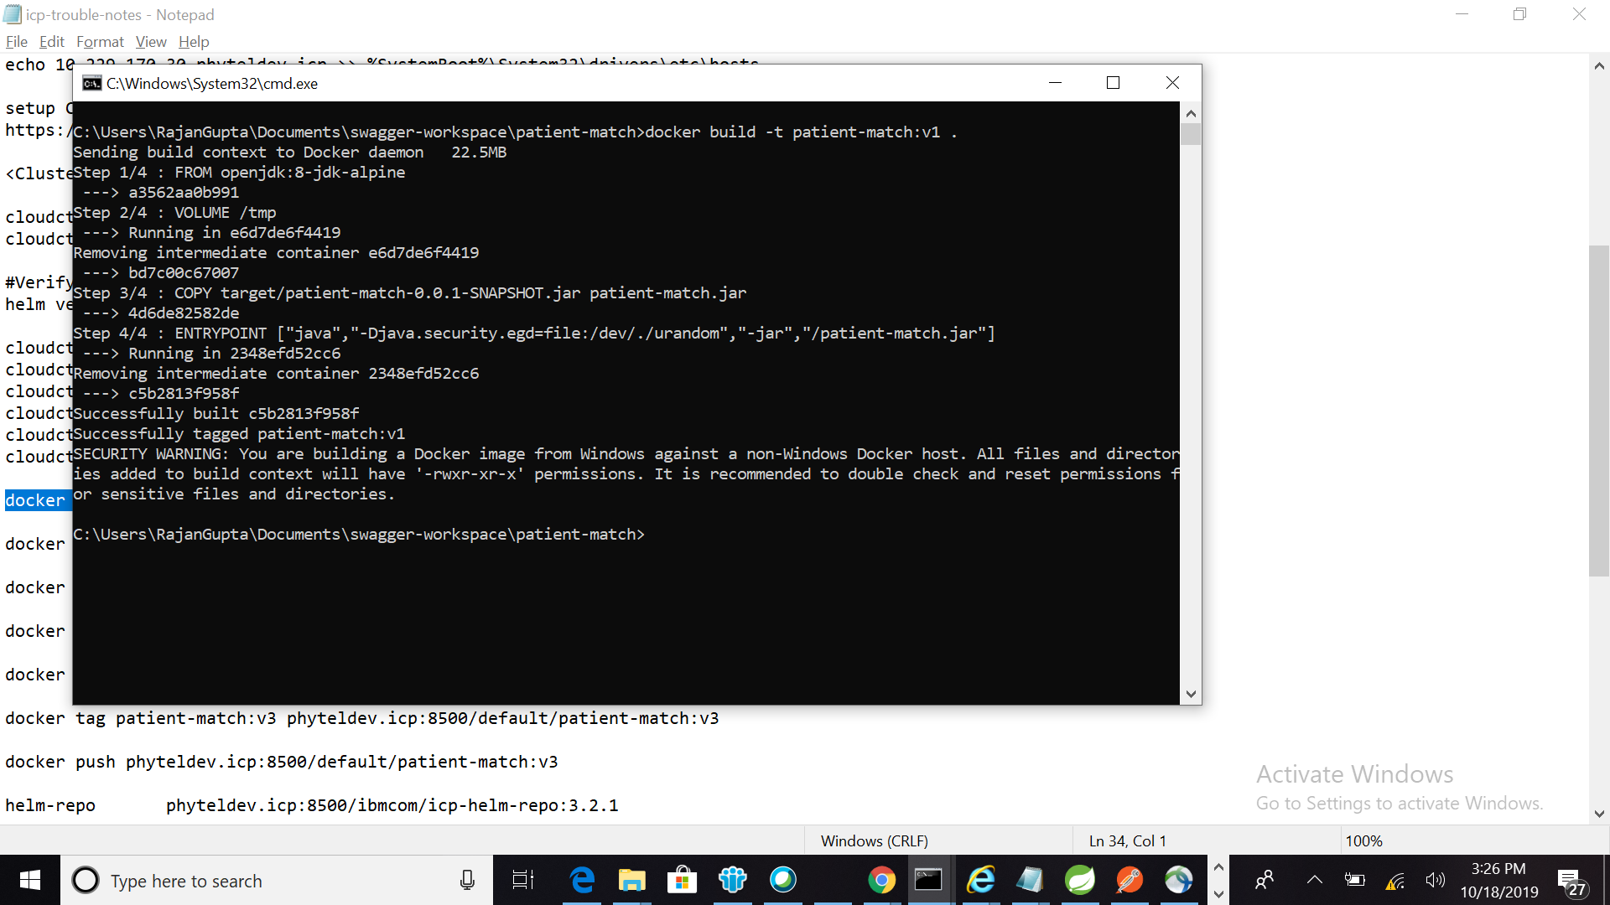

* Tag application image and push:

docker tag patient-match:v1 phyteldev.icp:8500/default/patient-match:v1

docker push phyteldev.icp:8500/default/patient-match:v1

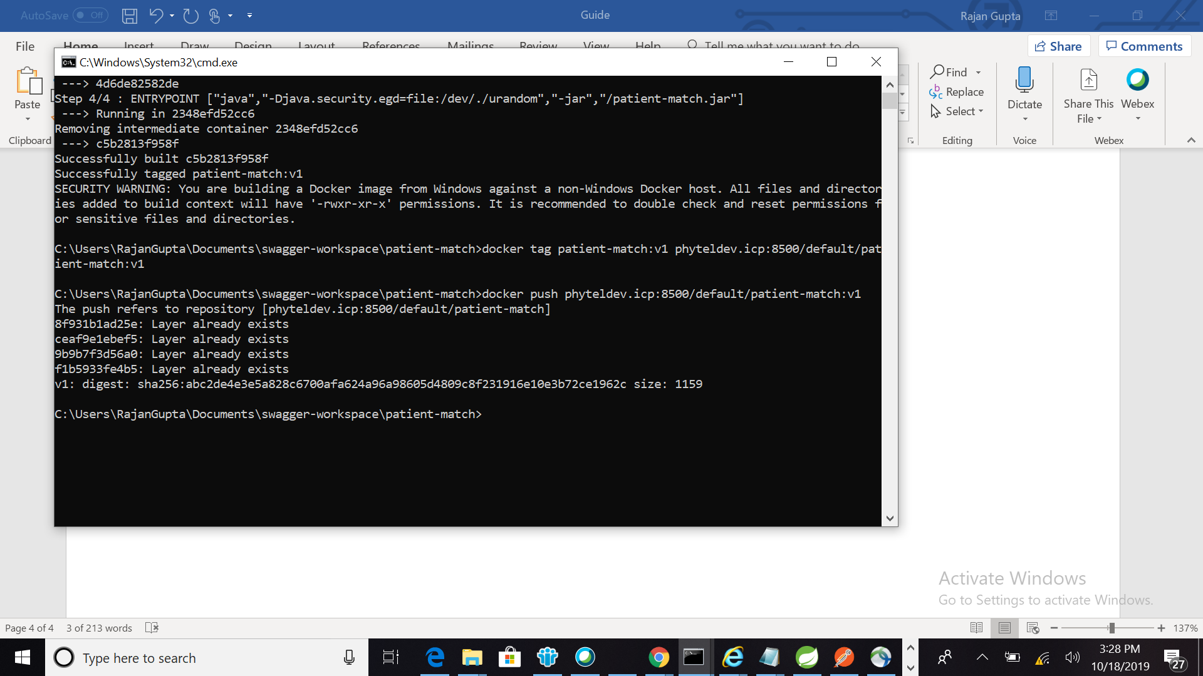

* Login to ICP cluster verify application image is available under Container Images

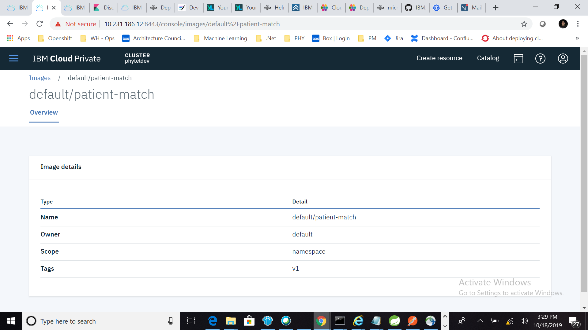

# Deploy Patient Match via Helm Chart

* #Verify that the Helm CLI is initialized. Client and Server version should match

helm version –tls

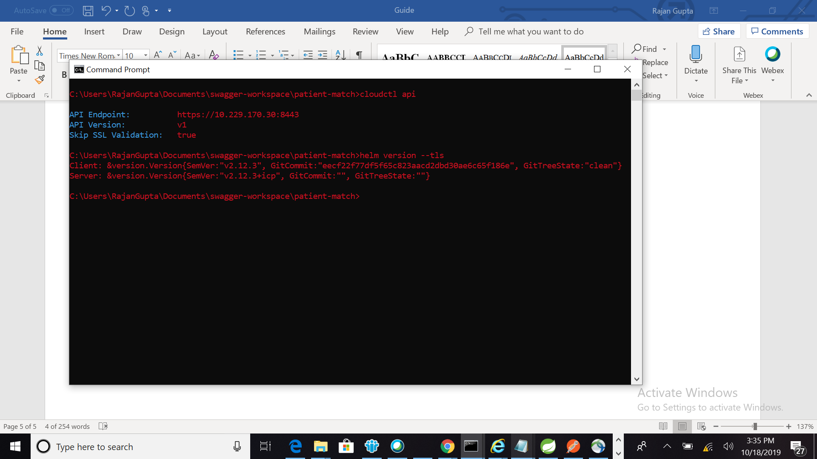

* #Navigate to application directory were helm chart is located

Install helm chart with below command

helm install --name patient-match-v1 --namespace default --tls patient-match-chart

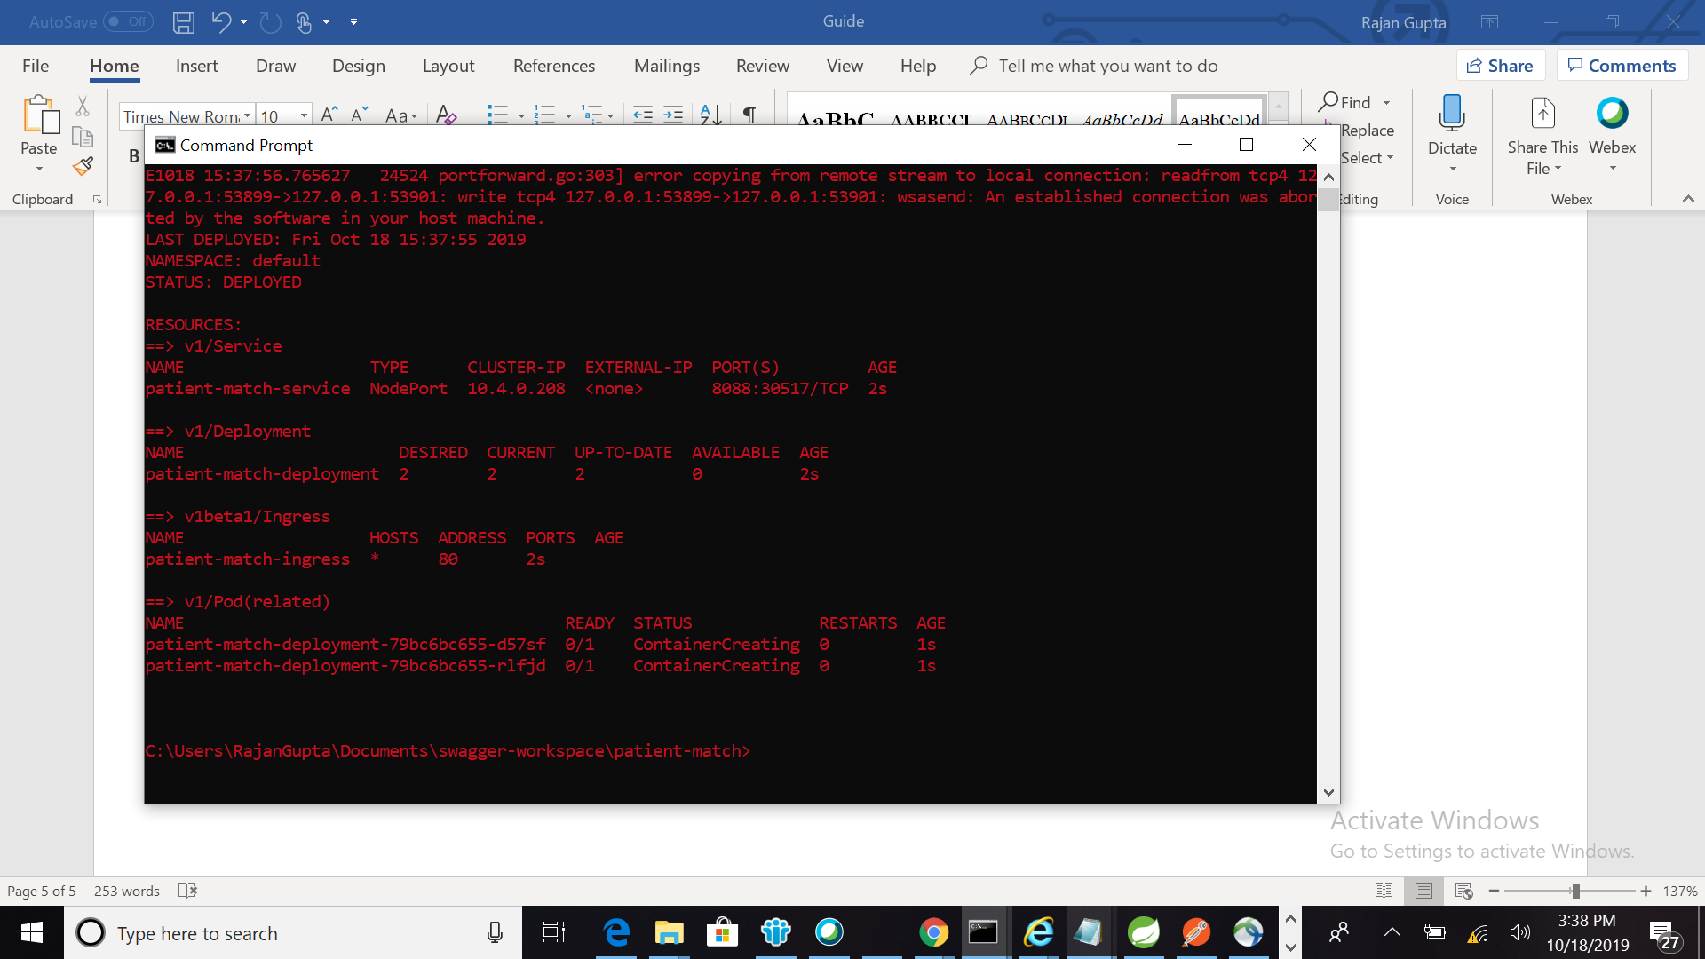

* # Login to ICP cluster verify deployment, service, ingress and pod are running

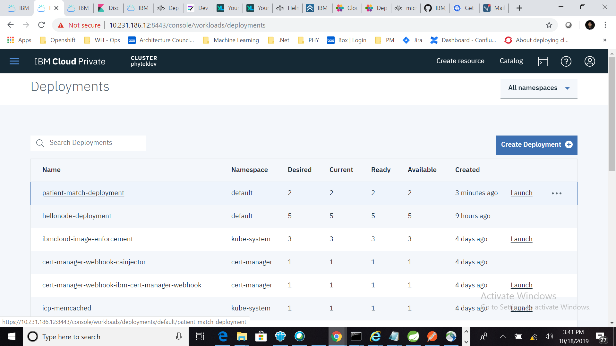

* Detail View Patient Match Deployment

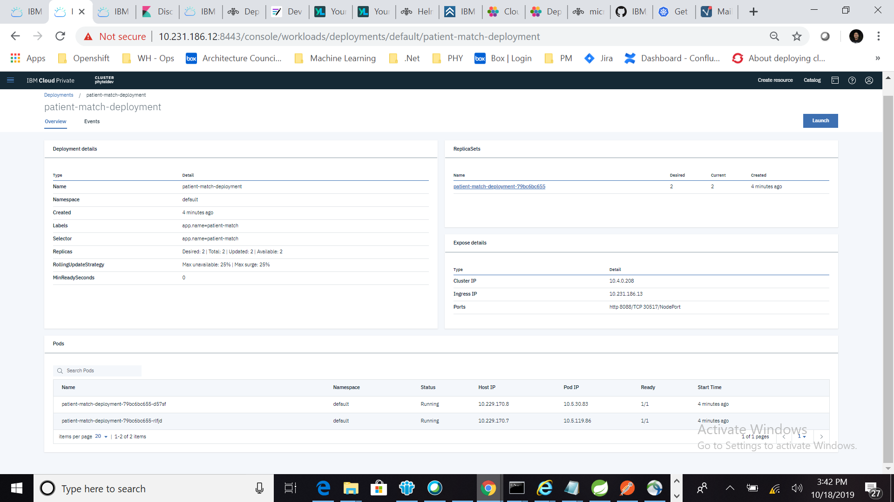

# Access Container Logs as Stream

* kubectl logs --follow patient-match-deployment-79bc6bc655-d57sf c patient-match

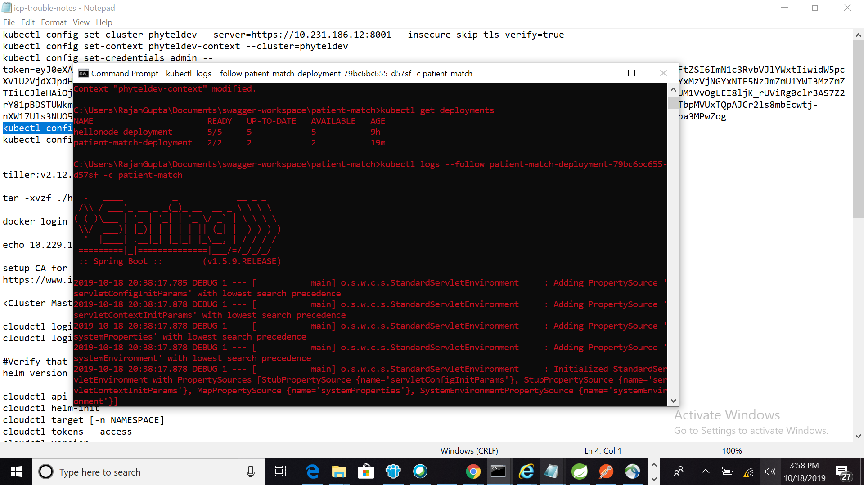 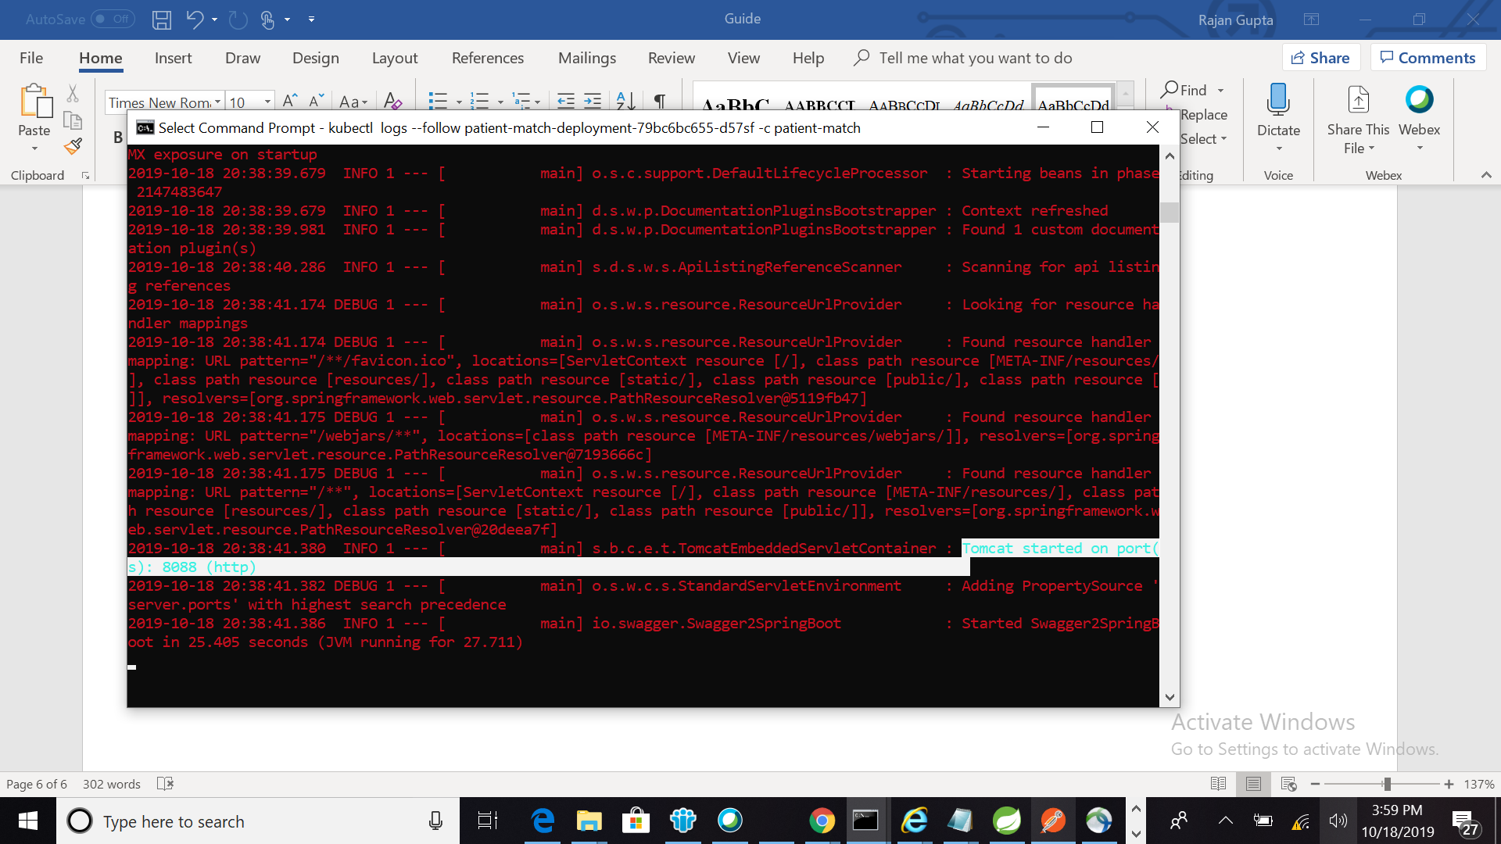

# Access your service

* Since application Helm char used nortPort Type deployment; So use NodeID: Port to access service
* Example of Patient Match Swagger End Point

GET curl [http://10.229.170.8:30517/api-docs](http://10.229.170.8:32681/api-docs)

Return swagger contract json

